**ViQu – A smart viva and quizzing solution**

**Capstone Project Proposal**

**Submitted by:**

101503208 Shivam Sharma, BE Third Year, COE-10

101503211 Shobhit Jain, BE Third Year, COE-10

101503213 Shreya Aggarwal, BE Third Year, COE-10

Capstone Team No.: CPG28

Under the Mentorship of

Dr. Maninder Kaur & Mr. Ashish Girdhar

Assistant Professor Lecturer

Computer Science and Engineering Department

Thapar Institute of Engineering and Technology, Patiala

April 2018

Contents

Use Case Diagram: 1

Use Case Template: 2

Tasks and Subtasks: 4

Activity Diagram: 6

Work Breakdown Structure: 7

Gantt Chart: 8

Functional Analysis: 9

Viva/Interview module: 9

Quiz module: 9

Setup module: 10

Non-Functional Analysis: 11

Performance requirement: 11

Product Cost: 11

Hardware used: 11

Software used: 11

Security: 12

# 

# Use Case Diagram:

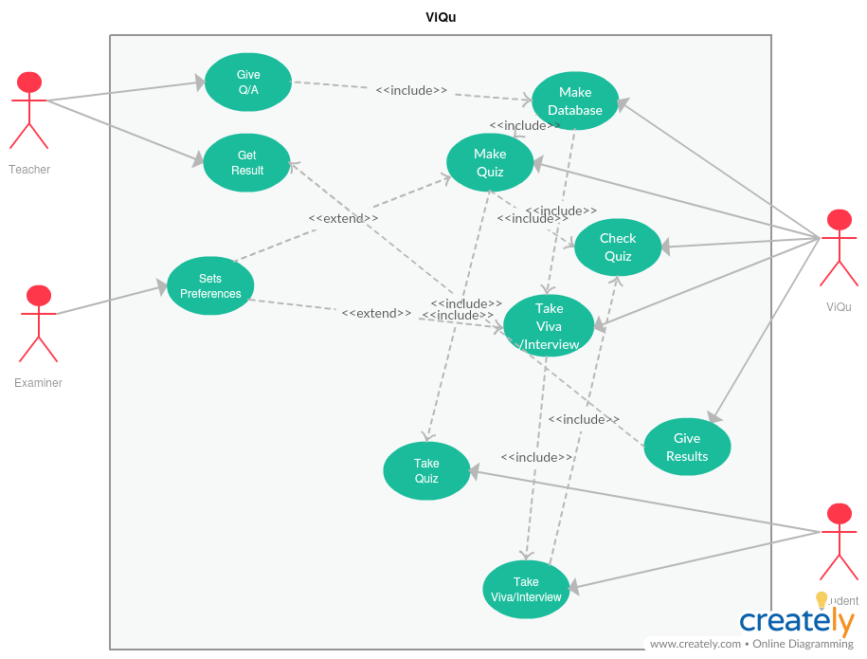

# Use Case Template:

|  |  |  |  |
| --- | --- | --- | --- |
| Use Case ID: | UID-101 | | |
| Use Case Name: | Interviewing/Viva and Quiz system | | |
| Created By: | CPG28 | Last Updated By: | CPG28 |
| Date Created: | April 2nd, 2018 | Date Last Updated: | April 3rd, 2018 |

|  |  |
| --- | --- |
| Primary Actor: | Examiner |
| Secondary Actor: | Student, Teacher,ViQu |
| Description: | Teacher needs to submit questions and answers to ViQu, ViQu will make the database of these Q/A.ViQu will use the database for quizzing and taking interview/viva, Students will take the interview and quiz and ViQu will evaluate them for interview/viva it will use text summarization (using natural language processing) and for quiz it will use image processing to find out marked answers, these answers will be submitted to teacher. |
| Preconditions: | 1. Hardware should be working correctly.  2. Interview/Viva should be in English.  3. Proper image should be provided for checking the quizzes.  4. Q/A should be provided by the teacher.  5. Extra disk space may be required.  6. Presence of the examiner may be required. |
| Postconditions: | 1. ViQu can calculate the marks according to the students’ performance.  2. Teacher can view the marks allotted by the ViQu.  3. Teacher can update the marksheet, if needed.  4. Question bank can also be generated using the database. |
| Minimal Condition: | 1. Database will be generated.  2. Quizzes will be generated.  3. Results will be provided. |
| Frequency of Use: | 1. The process of Interviewing/Viva and Quiz depends upon the number of participants.  2. Question/Answer and updating of database will occur every month. |
| Trigger: | 1. Providing Q/A will trigger Database.  2. Database will trigger Quiz making.  3. Taking interview will trigger taking interview/viva by ViQu.  4. Providing quiz pictures will trigger checking quizzes.  5. Any kind of evaluation will result in result generation. |
| Variations: | 1. Question/Answer can be provided as text file or as excel file.  2. Pictures may be directly provided to the system instead of making ViQu take them. |
| Extensions: | End session if input not provided for too long. |
| Assumptions: | 1. Students responds in English.  2. Pictures provided for checking viva should be in good quality. |

# Tasks and Subtasks:

1. Identification of project
2. Planning of project and need analysis
   1. Planning
   2. Scope plan
3. Study
   1. NLP
   2. Image Analysis
   3. Raspberry Pi
4. Designing of various diagrams
   1. Use-case diagram
   2. Activity diagram
   3. Work Breakdown Structure
5. Hardware interfacing
   1. Setup of Raspberry Pi 3
      1. Setup sensors
         1. Camera
         2. Mic
      2. Setup Actuators
         1. Speaker
      3. Validating interfacing
6. Software interfacing
   1. Setup Module
      1. Create GUI (using Python – Tkinter library)
      2. Create Different modules for Viva/Interview and Quiz setup
   2. Viva/Interview Module
      1. Viva/Int erview Generator
         1. Question Bank Creation
         2. Question Selector based on difficulty
      2. Viva/Interviewing process module
         1. Text-to-speech module (for asking questions)
         2. Speech-to-text module (for registering response)
         3. Storage module
      3. Viva/Interview Processor
         1. Text-summarization module (using NLP)
         2. Keyword Extractor
         3. Grade Analyzer
         4. Spreadsheet Creator
   3. Quiz Module
      1. Quiz Generator
         1. Question Bank Creation
         2. Question Selector based on difficulty
      2. Quiz Analyzer
         1. Image Capturing module (using object recognition)
         2. Roll no./Candidate ID detection module (using ODR)
         3. Blue Tick Detection module (using Image analysis)
         4. Marking module
         5. Spreadsheet Creator

1. Integration
   1. Software and Hardware integration
   2. Module integration
2. Testing
   1. Unit testing
   2. Module testing
   3. System testing
   4. Acceptance testing
3. Deployment
   1. Beta testing
   2. Modifications
4. Evaluations

# Activity Diagram:

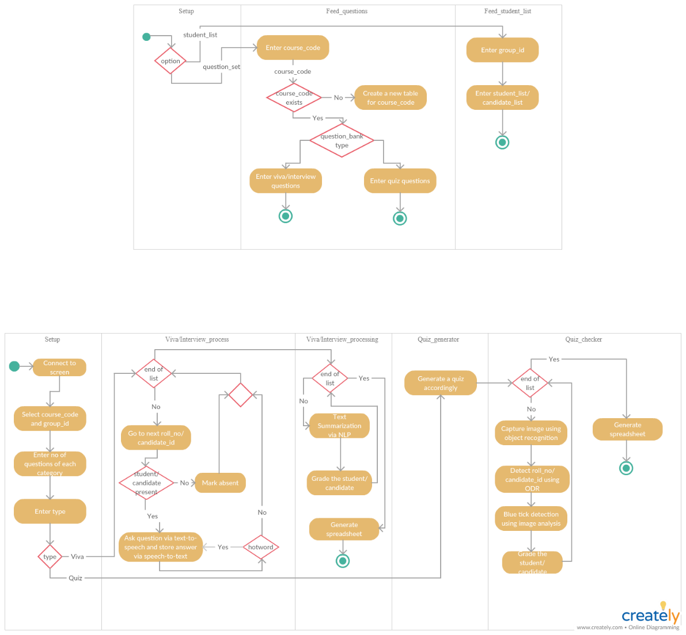

# Work Breakdown Structure:

**Semester 6**

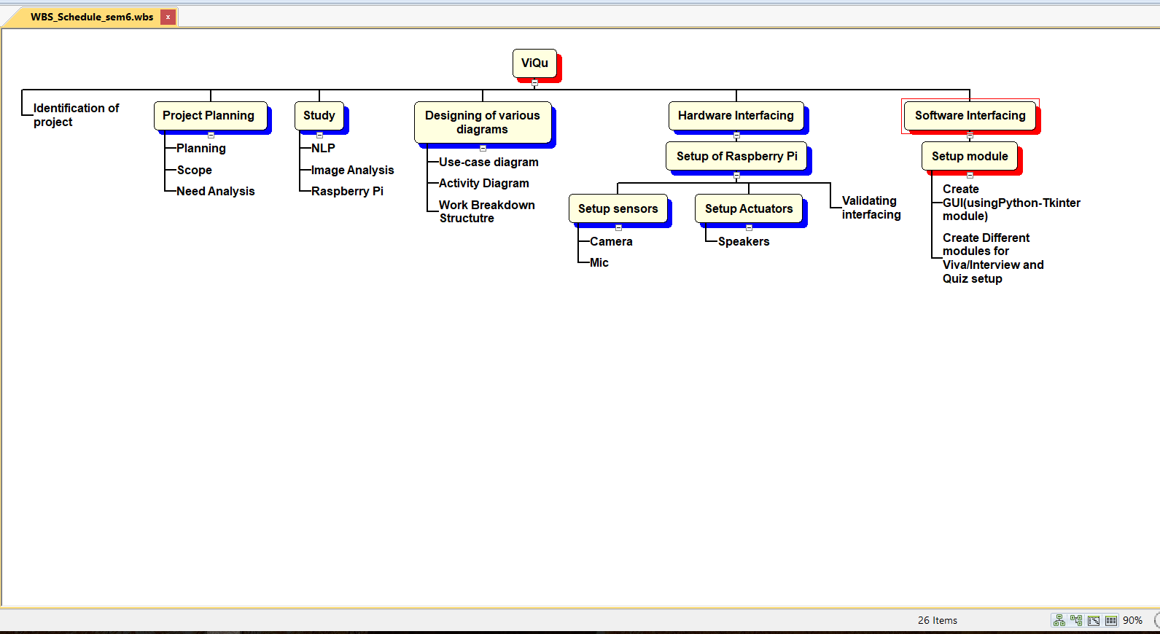

**Semester 7**

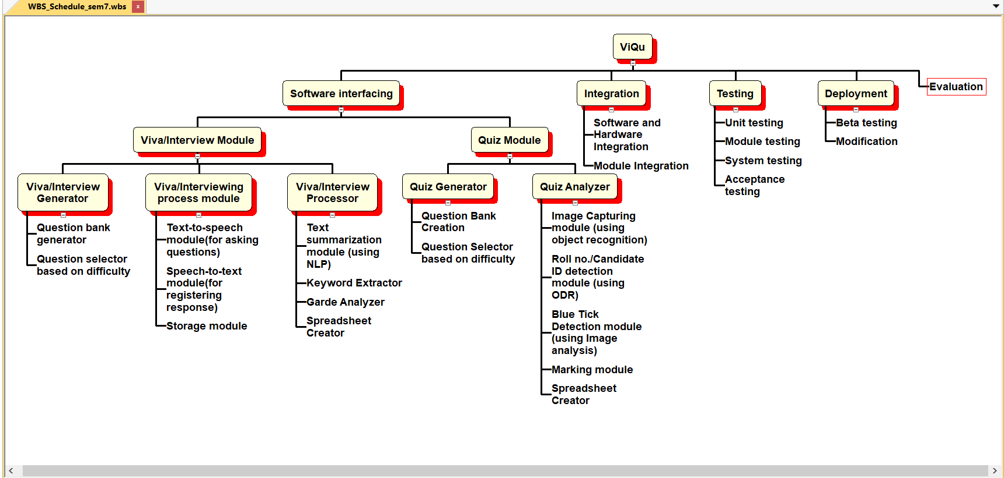

# Gantt Chart:

**Semester 6**

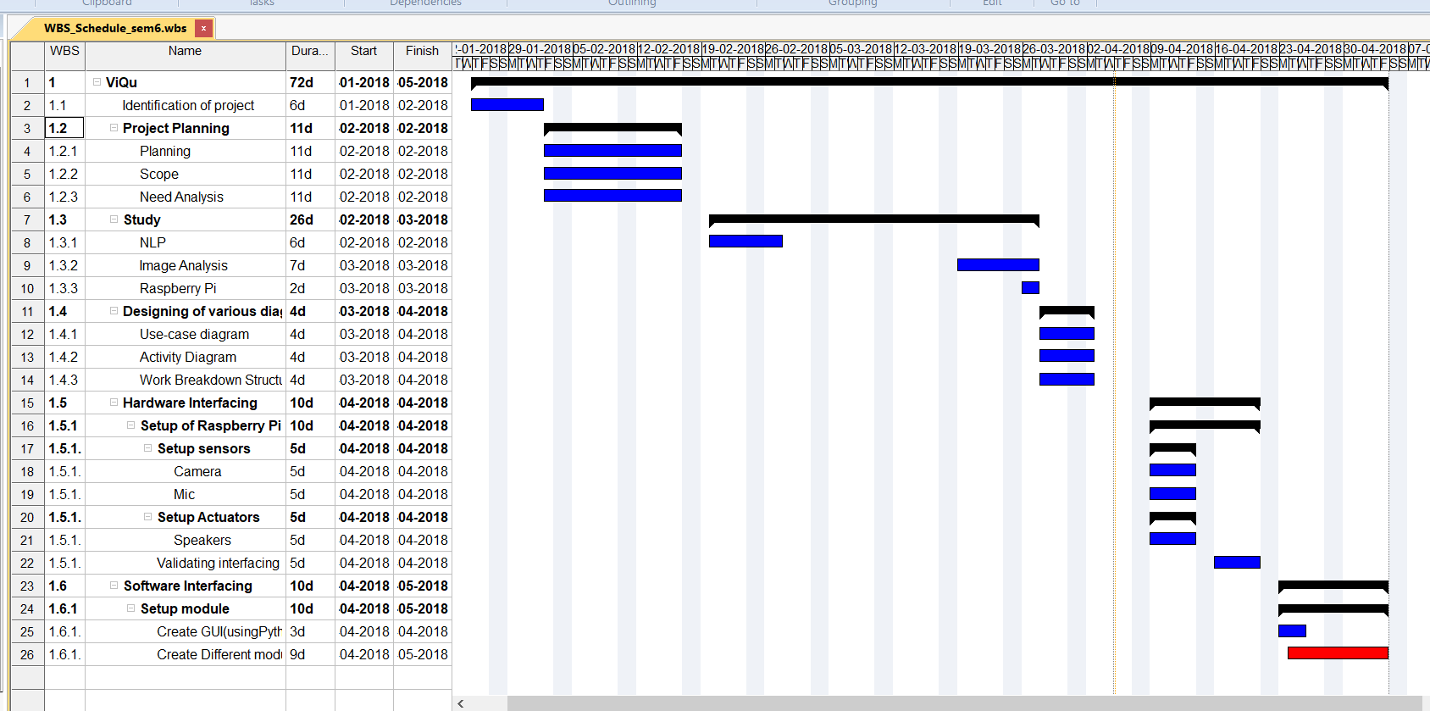

**Semester 7**

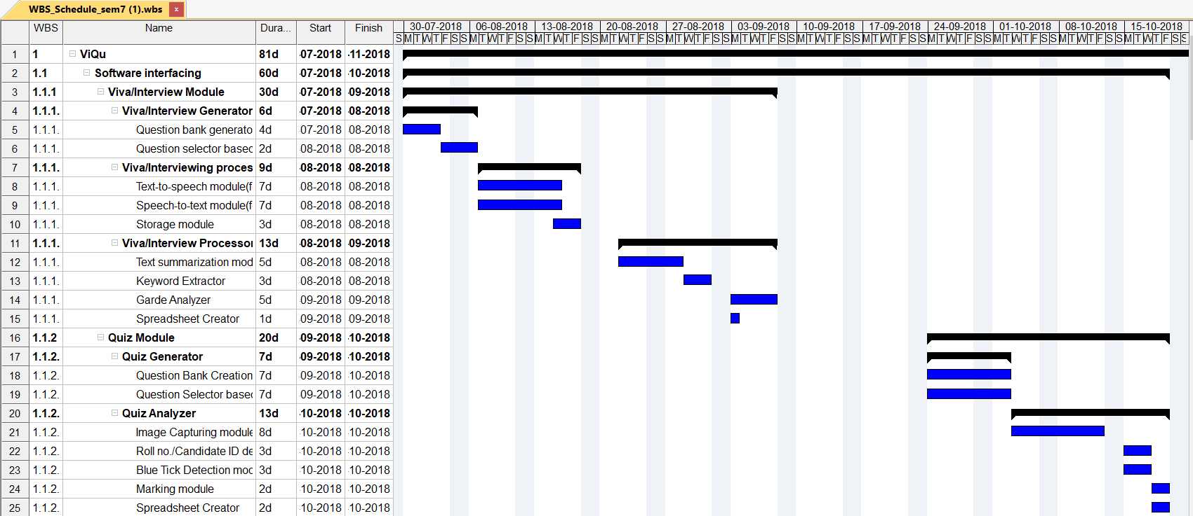

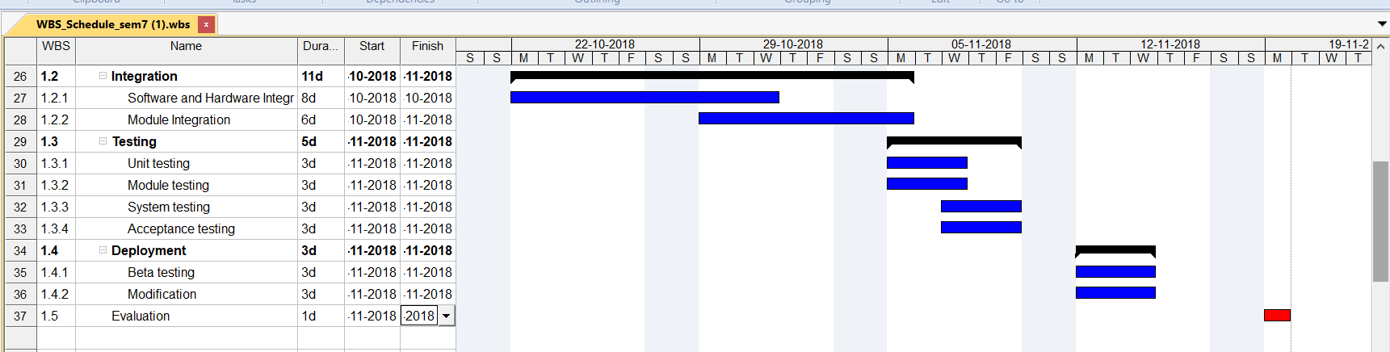

# Functional Analysis:

## Viva/Interview module:

* This module will fetch questions from the database to create a set of questions to be asked based on examiner preferences of difficulty level in the viva/interview.
* It will ask the candidate the set of questions created above using text-to-speech software module.
* It will record the response of the candidate to the asked question using speech-to-text software module.
* The recorded text above will then be summarized using the text-summarization software module.
* Also, the desired keywords will be searched in the candidate’s response.
* Based on certain parameters of marking such as number of keywords required and relevance to the actual answer, marks will be awarded on a scale of 5.
* Finally, when all the questions have been asked a summary of the viva/interview is created with the final score.
* Also, in case of multiple candidates a spreadsheet can also be created with the details of all the candidates.

## Quiz module:

* This module will fetch questions from the database to create a set of questions to be asked based on examiner preferences of difficulty level in the viva/interview.
* A quiz will be generated according to the difficulty required.
* After the candidates have taken the quiz, the quiz sheet is scanned via the camera attached to the device.
* The module scans the roll number/candidate id from the sheet using ODR software module.
* Now it detects the blue colored ticks on the multiple-choice questions and evaluates it.
* Finally, it enters the score of the candidate in the spreadsheet.

## Setup module:

* This module is used by the examiner to setup the device for various requirements of the viva/interview/quiz.
* The examiner can enter the number of questions to be asked.
* The examiner can enter the difficulty level of the viva/interview/quiz required.

# Non-Functional Analysis:

## Performance requirement:

* This is a hardware-based project, so the actual performance of the device is dependent on the hardware we choose to build it.
* Moreover, the project has various resource hungry software modules like text summarizer, ODR ,etc hence hardware is to be chosen careful.

## Product Cost:

Since it is a hardware-based project various device must be bought to create it.

The estimated budget related to these devices are as follows:

1. Raspberry Pi 3 - ₹3150
2. Mic - ₹500
3. Camera - ₹1000
4. Speakers - ₹350

**Total** - **₹5000**

## Hardware used:

1. Raspberry Pi
2. Mic
3. Camera
4. Speakers

## Software used:

1. Python Language
2. Python libraries
   1. Tkinter
   2. Keras
   3. Pytessaract
   4. Text-to-speech library
   5. Speech-to-text library
3. OS for Raspberry Pi 3

## Security:

Since the device is always in the control of examiner, the students can never temper with it. Also to make it more secure we will be providing a feature where the final spreadsheet of marks can only be open with the help of a password, further making the data more secure.

Moreover, the device is not connected to the network, so it is not hackable.